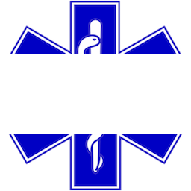

Muhlenberg College EMs Dispatch Application

User Guide

MCEMS: Dispatch Application - User Guide

Muhlenberg College

2400 Chew Street | Allentown | PA 18104

**Step 1** – Visit the Log-in screen at **https://dispatch.bergems.org**.

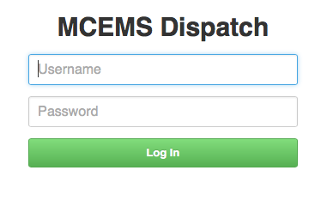

**Step 2** – Enter your credentials and click **Log In**.

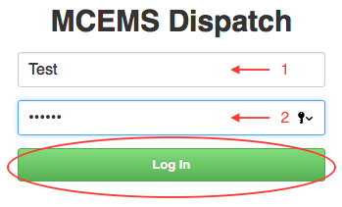

**Step 3** – Fill out the form (Note: The red fields are *required*; leaving them empty will prevent you from sending the alert)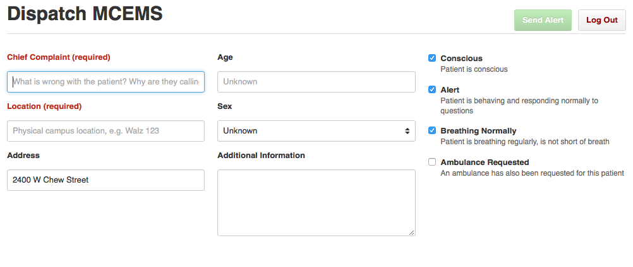

**Step 4** – Once the form is filled out, click **Send Alert** on the top right. When your message is sent, you will be alerted to the successful delivery of your message. Otherwise, you will be instructed to dispatch an EMT by radio.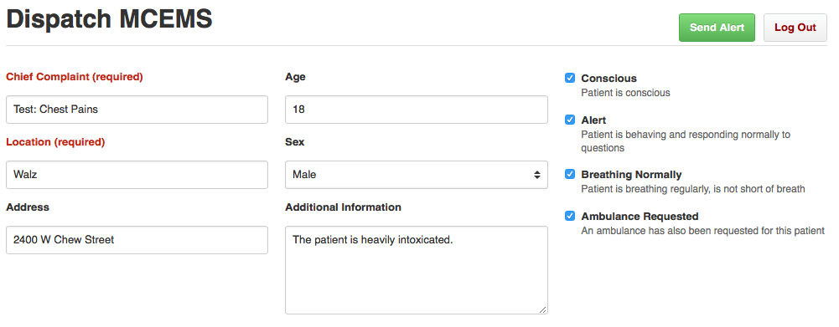

**Step 5** – Once you are finished, you can exit the form by clicking **Log Out** on the top right hand corner, and you will be taken back to the login screen.